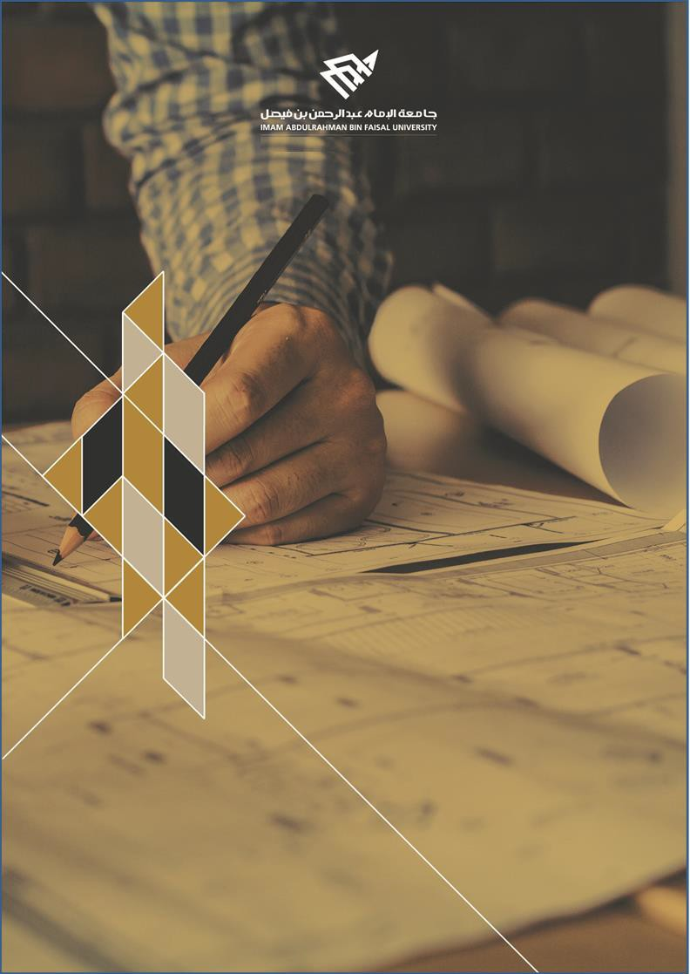

College of Computer Science and Information Technology
تامولعملا ةينقتو بساحلا مولع ةيلك

DEPARTMENT OF COMPUTER ENGINEERING

ARTI404 – Image Processing

STUDENT PROCEDURAL MANUAL Lab 2

2025 - 2026

College | Department | Course
College of Computer Science and Information Technology | Department of  Computer Engineering | ARTI404 – Image  Processing

Practical Session Plan

Session Topic/Title | Session No. | Session Duration  (Minutes)
Digital Image Fundamentals | 2 | 100

1- Session Outcomes

Outcome#1: Explain how digital images are represented and manipulated in a computer.

2- Tool(s)/Software .
• Python 3
• Anaconda
• IDE for Python: Jupyter, Spyder.
• Libraries: Pillow, OpenCV

3- Procedural steps (Tasks)

Image Sampling and Quantization

Step#1: Import the libraries
import cv2
import numpy as np
import matplotlib.pyplot as plt

Step#2: Define Functions

def sample_image(image, factor):
"""
Downsamples the image by the given factor.
Args:
image (numpy array): Original image.
factor (int): Factor by which to downsample.
Returns:
numpy array: Downsampled image.
"""
height, width = image.shape[:2]
sampled_image = cv2.resize(image, (width // factor, height // factor), interpolation=cv2.INTER_NEAREST)
return sampled_image

def quantize_image(image, levels):
"""
Reduces the number of grayscale levels in the image.
Args:
image (numpy array): Original image.
levels (int): Number of grayscale levels.
Returns:
numpy array: Quantized image.
"""
quantized_image = np.floor(image / (256 // levels)) * (256 // levels)
quantized_image = quantized_image.astype(np.uint8)
return quantized_image

def plot_images(original, sampled, quantized):
"""
Plots the original, sampled, and quantized images side by side.
Args:
original (numpy array): Original image.
sampled (numpy array): Sampled image.
quantized (numpy array): Quantized image.
"""
plt.figure(figsize=(12, 4))
plt.subplot(1, 3, 1)
plt.imshow(original, cmap='gray')
plt.title('Original Image')
plt.axis('off')

plt.subplot(1, 3, 2)
plt.imshow(sampled, cmap='gray')
plt.title('Sampled Image')
plt.axis('off')

plt.subplot(1, 3, 3)
plt.imshow(quantized, cmap='gray')
plt.title('Quantized Image')
plt.axis('off')

plt.show()

Step#3: Import the image and set the parameters

image_path='../images/lena_gray_256.tif'
sampling_factor=14
quantization_levels=9

# Load image in grayscale
original_image = cv2.imread(image_path, cv2.IMREAD_GRAYSCALE)
if original_image is None:
print(f"Error: Unable to load image at {image_path}")

# Sample and quantize
sampled_image = sample_image(original_image, sampling_factor)
quantized_image = quantize_image(original_image, quantization_levels)

# Plot results
plot_images(original_image, sampled_image, quantized_image)

Arithmetic Operations

from PIL import Image
img1=Image.open('../images/lena_gray_256.tif')
img2=Image.open ('../images/cameraman.tif')

resize=(400,400)
img1=img1.resize(resize,Image.Resampling.LANCZOS)
img2=img2.resize(resize,Image.Resampling.LANCZOS)

im1arr=np.asarray(img1)
im2arr=np.asarray(img2)

addition=im1arr+im2arr
resultImage=Image.fromarray(addition)
resultImage.show()

Sets and Logical Operations

img3=Image.open('../images/A.png')
img3.show()
img4=Image.open('../images/B.png')
img4.show()

resize=(400,400)
img3=img3.resize(resize,Image.Resampling.LANCZOS)
img4=img4.resize(resize,Image.Resampling.LANCZOS)

im3arr=np.asarray(img3)
im4arr=np.asarray(img4)

union=im4arr|im3arr
resultImage2=Image.fromarray(union)
resultImage2.show()

Practical Session Plan

Task#1: Change the sampling and quantization parameters and observe the effects.

Task#2: Read two images, convert them into an array, and perform the following operations on them.
- Subtract two images and display the result.
- Add one image with a constant value of 175 and display it.
- Apply the set difference operation on two Gray-Scale images.
- Apply the symmetric difference operation on two Gray-Scale images.
- Apply Intersection operations on two Gray-Scale images.

4- Assessment

The student will be asked to accomplish the tasks within the lab time.

5- Resources

OpenCV documentation

